
Measuring what matters: tracking climate adaptation processes and outcomes for smallholder producers in the agriculture sector

Deliverable 5: Systematic Map

June 201 v03

Jennifer Denno Cissé*, jenn@bristlep.com, USA, Bristlepine Resilience Consultants
Zarrar Khan, zarrar@bristlep.com, USA, Bristlepine Resilience Consultants
Caroline G. Staub, caroline@bristlep.com, USA, Bristlepine Resilience Consultants

Keywords: Climate Adaptation, Adaptation Outcomes, Adaptation Process, Smallholder Farmers, Monitoring and Evaluation (M&E), Agriculture

1. Key findings
This document presents a systematic map of methods used to track and measure climate adaptation processes and outcomes for smallholder producers in LMICs. This report is based on 154 studies coded across nine batches (those included after full-text screening of a randomly selected 180 papers). Seven findings stand out:
- Rigorous experimental approaches (like randomized control trials) and modeling with empirical validation are exceptionally rare: Only 7% of coded studies use experimental designs. Quantitative and qualitative methods dominate. The evidence base can describe what was implemented but cannot prove whether it improved outcomes.
- Producer bias: Adaptation research overwhelmingly targets crop farmers. Fisheries/aquaculture and agroforestry account for 12% of producer-type tags combined. These producer systems, critical across tropical LMICs, are nearly invisible in the evidence base.
- Institutional governance appears in only 18 of 604 study-domain instances (154 studies) across all producer types: The systemic conditions that determine whether adaptation reaches people are almost entirely unmeasured. Access to services appears in only 35 of 604 instances (154 studies).
- Highly vulnerable groups remain largely underrepresented in the literature: 39% of coded studies do not specifically target marginalized groups. Where they do, it is mostly women, indigenous peoples and youth. Disability, ethnic minorities, and the elderly appear in fewer than 2 studies each; indigenous peoples in 6 studies.
- Process over outcomes: Knowledge, adoption, and decision-making account for the majority of the evidence base. Income, wellbeing, resilience, and other impact outcomes are substantially underrepresented by comparison.
- Studies are heavily concentrated in Sub-Saharan Africa and South Asia. Ethiopia, Ghana, and Kenya alone account for 22% of all human-coded studies. Large evidence gaps persist across Central America, Southeast Asia, the Sahel, and MENA.

2. Background
A growing number of climate adaptation interventions and autonomous adaptation are being deployed across the agriculture sector to support smallholder producers in LMICs. Despite growing investment, a central challenge persists: how to measure the effectiveness of these interventions. Monitoring and evaluation (M&E) in this space is particularly complex, due to long timeframes, evolving climate baselines, terminological differences, and attribution challenges. This systematic map responds to these challenges by systematically identifying, and characterising the methods used to assess climate adaptation interventions in the agriculture sector, with a focus on smallholder producers in LMICs.

3. Methods
This systematic map was conducted in accordance with a pre-registered protocol (Cissé, Staub & Khan, 2025; https://doi.org/10.5281/zenodo.19811629), following CEE guidelines for systematic maps (Collaboration for Environmental Evidence, 2018) and reported in accordance with ROSES standards (Haddaway et al., 2018; https://doi.org/10.1186/s13750-018-0121-7).

3.1 Deviations from Protocol

The published systematic map protocol (Deliverable 3, v01; Zenodo DOI: 10.5281/zenodo.18370029) was amended prior to data collection. Four amendments were documented and published in the updated protocol (Deliverable 3, v03; Zenodo DOI: 10.5281/zenodo.19811629). This report follows the amended protocol in full; no further deviations occurred during implementation.

The four amendments are summarised below:

Amendment 1 - Deduplication method. The original protocol specified deduplication in Zotero using the Bramer et al. (2016) method. A multi-stage algorithmic approach was used instead: (1) exact DOI match; (2) exact title and year match; (3) fuzzy title similarity using the Jaccard coefficient (threshold ≥ 0.85). Scopus records served as the primary reference set; records from all additional sources were deduplicated against this corpus.

Amendment 2 - Screening tool. The original protocol specified title/abstract screening in EPPI-Reviewer by human reviewers. A validated LLM-assisted tool (Ollama; qwen2.5:14b) was used instead, applying the same PCCM eligibility criteria. The tool was calibrated across six iterative rounds against a reconciled human gold standard, reaching a sensitivity of 0.970 and Cohen's κ of 0.721 before full-corpus screening proceeded.

Amendment 3 - Full-text sampling approach. The original protocol specified data extraction across all included studies following full-text screening. Given the volume of records included at the title/abstract stage, a random sampling approach with an information saturation stopping rule was applied instead. Studies were drawn in batches; saturation was defined as fewer than 5% new codes across two consecutive batches.
- Amendment 4 - Codebook consolidation. The standalone equity and inclusion field (Field 16) was consolidated into the marginalized subpopulations field, extended with an 'other' category and free-text notes. The methodological approach field was revised from single-select to multi-select, with an experimental category added to cover randomised controlled trials and quasi-experimental designs.

3.2 Search strategy
The search strategy was designed to identify all available empirical and methodological literature relevant to the methods used to track and measure the impacts of climate adaptation interventions for smallholder producers in the agriculture sector. The strategy followed recognized standards for evidence synthesis (Collaboration for Environmental Evidence, 2018) and drew on multiple sources: (1) large bibliographic databases, (2) web-based search engines, (3) organizational and institutional gray literature repositories, and (4) citation chasing.
Searches were conducted using combinations of structured Boolean search strings tailored to each database’s syntax. Search terms reflected the PCCM framework (Population—Concept—Context—Methodological focus), including synonyms and variant terminology for smallholder producers, climate adaptation interventions, agricultural systems, and adaptation measurement methods.
Search terms for major sources were fully documented with precise search strings to enable replication. Searches of organizational websites and gray literature sources were conducted using flexible combinations of keywords appropriate to each site’s search capacity.
Searches were restricted to literature published from 2005 onward, reflecting the period in which adaptation metrics and outcome-oriented evaluation frameworks began to consolidate following major developments in IPCC and UNFCCC processes. Contemporary adaptation evaluation methods emerged largely after IPCC AR4 (2007), which elevated adaptation as a mainstream pillar of climate policy and highlighted methodological gaps, especially in assessing outcomes. The subsequent rollout of National Adaptation Programmes of Action (NAPAs), and later National Adaptation Plans (NAPs), generated sustained demand for structured monitoring, evaluation, and learning systems. Key methodological frameworks—including those from the GEF, OECD, Climate-ADAPT, UNDP, and the NAP Global Network—developed from 2010 onward, alongside the formalization of adaptation reporting under the Paris Agreement and the Global Goal on Adaptation. This cutoff does not limit the evidence base—preliminary testing showed no relevant methodological literature would be excluded by starting in 2005. Screening was limited to languages for which the review team had capacity—English, French, and Spanish. This reflected both feasibility and the distribution of relevant literature: preliminary searches found that non-English languages collectively accounted for a very small proportion of publications, with Chinese-language studies representing ~1% of results and rarely addressing methodological aspects of adaptation measurement. Given the global nature of adaptation M&E research and its concentration in English-language outlets, the risk of excluding relevant methodological work was low.

3.2.1 Bibliographic databases
We searched the following bibliographic databases, chosen for their coverage of environmental science, climate adaptation, agricultural research, development studies, and evaluation methodologies:

Primary Databases
- Scopus (Elsevier): Broad coverage of interdisciplinary climate and agricultural sciences.
  - Search fields: Title, abstract, keywords
  - Access: Cornell University subscription
- Web of Science Core Collection (Clarivate): Includes Science Citation Index Expanded (SCIE, 1900 to present), Social Sciences Citation Index (SSCI, 1900 to present), and Emerging Sources Citation Index (ESCI, coverage varies by journal).
  - Search fields: Title OR Abstract OR keyword
  - Access: Cornell University subscription
- CAB Abstracts (CABI): Core database for agriculture, smallholder producers, and rural development.
  - Search fields: Title, abstract, and index terms
  - Access: Cornell institutional subscription through EBSCOhost
- AGRIS (FAO): Agriculture and rural development, including gray literature.
  - Search fields: Keyword
  - Access: Open access
- Academic Search Premier (EBSCO): Development studies and evaluation methodologies.
  - Search fields: Title, abstract, subject terms
  - Access: Institutional subscription

Supplementary Sources for Methodological Completeness
In addition to the primary bibliographic databases, a small number of supplementary sources were searched to identify methodological papers, working papers, and file-drawer studies relevant to adaptation measurement approaches. These sources were searched using structured and documented search strategies aligned with the PCCM framework, adapted as needed to the syntax and functionality of each platform.
- EconLit (American Economic Association): Used to identify methodological papers related to impact evaluation, outcome measurement, and quasi-experimental methods relevant to adaptation M&E.
- ProQuest Dissertations & Theses Global: Used to locate unpublished or doctoral-level methodological work ("file-drawer" studies) that may include novel adaptation process or outcome metrics or monitoring frameworks.

Decomposition of Search String by Substring
Table 1 shows the decomposition of the search string with a tally of results by substring categories for the initial Scopus search shown in Figure 1.
Table 1: Search String Decomposition
Substring (PCCM element) | Search terms (grouped for readability) | Records returned (Scopus)
Population (P): Smallholder producers and marginalized subpopulations | Smallholder and small-scale producers  smallholder* OR "small holder*" OR "small-scale farmer*" OR "small-scale producer*" OR "subsistence farmer*" OR "farmers in low-income countr*" OR "small-scale farmers in low-income countr*" OR "marginal farmer*" OR "resource-poor farmer*" OR ((farmer* OR producer*) W/3 (smallholder* OR "small-scale" OR subsistence OR marginal* OR "resource-poor")) OR  Households and poverty-linked producer categories  "rural household*" OR "farm household*" OR "agricultural household*" OR "family farmer*" OR "low-income household*" OR "poor household*" OR "female-headed household*" OR "women-headed household*" OR ((household* OR family OR farmer*) W/3 (rural OR agricultural OR farm* OR "low-income" OR poor OR female-headed OR women-headed)) OR  Livestock- and pastoral-based producers  pastoralist* OR "agro-pastoralist*" OR "agro pastoralist*" OR herder* OR "livestock keeper*" OR "livestock farmer*" OR "livestock producer*" OR "dairy farmer*" OR "crop-livestock farmer*" OR (pastoralist* OR herder* OR ((farmer* OR producer* OR keeper*) W/3 (livestock OR dairy OR cattle OR crop-livestock)) OR "agro-pastoral*") OR  Fisheries and aquaculture producers  fisher* OR "small-scale fisher*" OR "small scale fisher*" OR fisherfolk OR "artisanal fisher*" OR "aquaculture producer*" OR "fish farmer*" OR "shrimp farmer*" OR ((fisher* W/3 (small-scale OR smallscale OR artisanal)) OR ((farmer* OR producer*) W/3 (aquaculture OR fish OR shrimp))) OR  Agroforestry and tree-based systems  "agroforestry farmer*" OR "agroforestry producer*" OR "tree crop farmer*" OR "fruit grower*" OR "forest farmer*" OR silvopastoral OR "silvo-pastoral" OR "tree-livestock farmer*" OR (((farmer* OR producer*) W/3 (agroforestry OR "tree crop*" OR fruit OR forest OR silvopastoral OR "tree-livestock"))) OR  Marginalized and underrepresented subpopulations  women OR female* OR "women farmer*" OR "female farmer*" OR youth OR "rural youth" OR "young farmer*" OR "young producer*" OR adolescent* OR "landless farmer*" OR "tenant farmer*" OR sharecropper* OR "contract farmer*" OR "Indigenous Peoples" OR "indigenous communit*" OR "tribal communit*" OR "ethnic minorit*" OR "agricultural laborer*" OR "farm worker*" OR "seasonal worker*" OR "migrant farmworker*" OR (((farmer* OR producer* OR household* OR laborer* OR worker*) W/3 (women OR female* OR youth OR adolescent* OR landless OR tenant OR sharecropper* OR contract OR Indigenous OR tribal OR "ethnic minorit*" OR migrant OR seasonal))) | 10,359,526
Concept (C): Adaptation processes and outcomes | Adaptation actions and processes  adapt* W/5 (practice* OR behav* OR decision* OR strateg* OR adjust* OR chang*) OR uptake OR adoption OR participat* OR "participatory process*" OR "adaptive management" OR learning* OR "learning process*" OR "feedback loop*" OR "feedback mechanism*" OR (governance W/5 (adapt* OR climate)) OR extension* OR insurance* OR  Capacities, knowledge, and governance  "adaptive capacity" OR (capacity W/3 (build* OR strengthen* OR expand* OR improv*)) OR (knowledge W/3 (adapt* OR climate OR resilience)) OR information* OR training* OR  Resilience, risk reduction, and well-being outcomes  (resilien* W/5 (outcome* OR capacity OR livelihood* OR improv* OR effect*)) OR (adapt* W/5 (outcome* OR impact* OR effect* OR capacity OR livelihood*)) OR (reduc* W/5 (risk OR "climate risk*" OR vulnerabilit* OR exposure*)) OR wellbeing OR "well-being" OR  Livelihood and productivity outcomes  livelihood* OR "coping strateg*" OR "coping capacit*" OR (income W/5 (stability OR variability OR loss*)) OR (yield W/5 (stability OR improved OR increased OR variability OR loss*)) OR increase* OR  Maladaptation  maladapt* OR "maladaptive outcome*" OR "maladaptive adaptation" | 18,457,055
Context (C): Climate stressors and hazards | Climate adaptation framing  (climate W/3 (change OR adapt* OR resilien* OR risk OR hazard* OR variability OR exposure* OR shock*)) OR "climate-resilient*" OR "climate-smart agriculture" OR CSA OR  Extreme events and climate hazards  (extreme* W/3 (climate OR heat OR weather OR rainfall OR aridity)) OR heatwave* OR "heat wave*" OR "heat stress" OR frost OR "cold spell" OR "heavy rainfall" OR "intense rainfall" OR drought* OR "water scarcity" OR "water stress" OR "aridity events" OR "dry spell" OR flood* OR "storm surge" OR "coastal erosion" OR "salinity intrusion" OR "saline intrusion" OR cyclone* OR hurricane* OR typhoon* OR (wind W/3 (storm OR gust* OR intens*)) OR "weather shock*" OR disaster* | 14,33,957
Context (C): Agricultural systems | agricultur* OR farm* OR crop* OR "food production" OR "livestock rearing" OR "animal husbandry" OR rangeland* OR fishery OR fisheries OR aquacultur* OR forestry OR agroforestry OR "tree crop*" OR silvopastoral OR "silvo-pastoral" OR "crop-livestock system" OR "mixed crop-livestock" OR "mixed farming" OR agroecolog* OR "integrated farming system*" OR irrigation* | 2,160,930
Context (C): LMICs | Countries  afghanistan OR albania OR algeria OR "american samoa" OR angola OR "antigua and barbuda" OR antigua OR barbuda OR argentina OR armenia OR aruba OR azerbaijan OR bahrain OR bangladesh OR barbados OR "republic of belarus" OR belarus OR byelarus OR belorussia OR belize OR "british honduras" OR benin OR dahomey OR bhutan OR bolivia OR bosnia OR herzegovina OR botswana OR bechuanaland OR brazil OR brasil OR bulgaria OR "burkina faso" OR "burkina fasso" OR "upper volta" OR burundi OR urundi OR "cabo verde" OR "cape verde" OR cambodia OR kampuchea OR "khmer republic" OR cameroon OR cameron OR cameroun OR "central african republic" OR "ubangi shari" OR chad OR chile OR china OR colombia OR comoros OR "comoro islands" OR "iles comores" OR mayotte OR congo OR zaire OR "costa rica" OR "cote d'ivoire" OR "cote d ivoire" OR "cote divoire" OR "ivory coast" OR croatia OR cuba OR cyprus OR "czech republic" OR czechoslovakia OR djibouti OR "french somaliland" OR dominica OR "dominican republic" OR ecuador OR egypt OR "united arab republic" OR "el salvador" OR "equatorial guinea" OR "spanish guinea" OR eritrea OR estonia OR eswatini OR swaziland OR ethiopia OR fiji OR gabon OR "gabonese republic" OR gambia OR "georgia (republic)" OR ghana OR "gold coast" OR gibraltar OR greece OR grenada OR guam OR guatemala OR guinea OR "guinea bissau" OR guyana OR "british guiana" OR haiti OR hispaniola OR honduras OR hungary OR india OR indonesia OR timor OR iran OR iraq OR "isle of man" OR jamaica OR jordan OR kazakhstan OR kenya OR korea OR kosovo OR kyrgyzstan OR kirghizia OR kirgizstan OR "kyrgyz republic" OR laos OR "lao pdr" OR "lao people's democratic republic" OR latvia OR lebanon OR "lebanese republic" OR lesotho OR basutoland OR liberia OR libya OR "libyan arab jamahiriya" OR lithuania OR macau OR macao OR macedonia OR madagascar OR "malagasy republic" OR malawi OR nyasaland OR malaysia OR "malay federation" OR "malaya federation" OR maldives OR mali OR malta OR micronesia OR kiribati OR "marshall islands" OR nauru OR "northern mariana islands" OR palau OR tuvalu OR mauritania OR mauritius OR mexico OR moldova OR mongolia OR montenegro OR morocco OR ifni OR mozambique OR "portuguese east africa" OR myanmar OR burma OR namibia OR nepal OR "netherlands antilles" OR nicaragua OR niger OR nigeria OR oman OR muscat OR pakistan OR panama OR "new guinea" OR paraguay OR peru OR philippines OR philipines OR phillipines OR phillippines OR poland OR "polish people's republic" OR portugal OR "portuguese republic" OR "puerto rico" OR romania OR russia OR "russian federation" OR ussr OR "soviet union" OR "union of soviet socialist republics" OR rwanda OR ruanda OR samoa OR "pacific islands" OR polynesia OR "samoan islands" OR "navigator island" OR "navigator islands" OR "sao tome and principe" OR "saudi arabia" OR senegal OR serbia OR seychelles OR "sierra leone" OR slovakia OR "slovak republic" OR slovenia OR melanesia OR "solomon island" OR "solomon islands" OR "norfolk island" OR "norfolk islands" OR somalia OR "south africa" OR "sri lanka" OR ceylon OR "saint kitts and nevis" OR "st. kitts and nevis" OR "saint lucia" OR "st. lucia" OR "saint vincent and the grenadines" OR "saint vincent" OR "st. vincent" OR grenadines OR sudan OR suriname OR surinam OR "dutch guiana" OR "netherlands guiana" OR syria OR "syrian arab republic" OR tajikistan OR tadjikistan OR tadzhikistan OR tanzania OR tanganyika OR thailand OR siam OR "timor leste" OR "east timor" OR togo OR "togolese republic" OR tonga OR trinidad OR tobago OR tunisia OR turkey OR turkmenistan OR uganda OR ukraine OR uruguay OR uzbekistan OR vanuatu OR "new hebrides" OR venezuela OR vietnam OR "viet nam" OR "west bank" OR gaza OR palestine OR yemen OR yugoslavia OR zambia OR zimbabwe OR "northern rhodesia" OR  Regions  africa OR "sub-saharan africa" OR "north africa" OR "west africa" OR "east africa" OR "southern africa" OR "central africa" OR sahara OR magreb OR maghrib OR "latin america" OR "central america" OR "south america" OR "south and central america" OR caribbean OR "west indies" OR "middle east" OR mena OR asia OR "central asia" OR "east asia" OR "south asia" OR "southeast asia" OR "south east asia" OR "south eastern asia" OR "western asia" OR "north asia" OR "northern asia" OR "eastern europe" OR "east europe" OR "europe, eastern" OR "indian ocean" OR "indian ocean islands" OR "pacific islands" OR "pacific islander*" OR "global south" OR  LMICS Descriptors  lmic OR lmics OR "developing country" OR "developing countries" OR "developing nation*" OR "developing population*" OR "developing world" OR "less developed countr*" OR "less developed nation*" OR "less developed population*" OR "less developed world" OR "lesser developed countr*" OR "lesser developed nation*" OR "lesser developed population*" OR "lesser developed world" OR "under developed countr*" OR "under developed nation*" OR "under developed population*" OR "under developed world" OR "underdeveloped countr*" OR "underdeveloped nation*" OR "underdeveloped population*" OR "underdeveloped world" OR "low income countr*" OR "low income nation*" OR "low income population*" OR "lower income countr*" OR "lower income nation*" OR "lower income population*" OR "middle income countr*" OR "middle income nation*" OR "middle income population*" OR "poor countr*" OR "poor nation*" OR "poor population*" OR "third world" OR "emerging econom*" OR "emerging economies" OR "emerging nation*" | 7,229,367
Methodological focus (M): Measurement and evaluation | indicator* OR metric* OR "measurement framework*" OR monitor* OR evaluat* OR assess* OR "impact evaluation" OR "results-based management" OR "results based management" OR "M&E" OR MEL OR effectiv* OR impact* OR (measur* W/5 (adapt* OR resilience OR outcome*)) OR index OR indices OR "data collection" OR survey* OR (participatory W/3 (monitoring OR method* OR assessment)) OR "mixed methods" | 28,789,562
2005 onwards | PUBYEAR > 2004
Combined Strings | Combined | 16,894

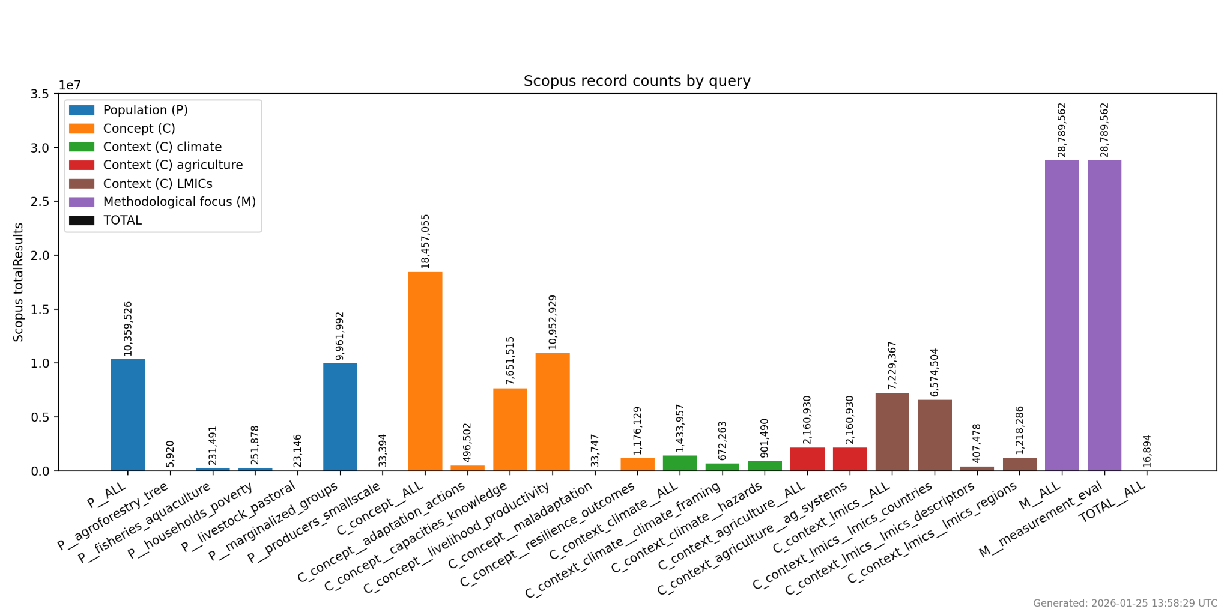
Figure 1: Scopus Search String Results by Query

3.2.2 Web-based search engines
Web-based search engines were used to retrieve academic and gray literature not captured in bibliographic databases.
- Google Scholar
- DuckDuckGo (to reduce personalization bias)
Approach:
- Used extended but simplified Boolean-style search strings aligned with the core PCCM framework, taking advantage of Google Scholar’s expanded character limits while remaining within platform constraints.
- Screened first 200 results per string, consistent with CEE guidance.
- Recorded search date, search terms, and number of hits.

Example Google Scholar String
"climate adaptation" smallholder
("adaptation process" OR "adaptation outcome" OR "adaptive capacity" OR "climate resilience" OR livelihoods OR wellbeing)
(indicator OR metric OR measurement OR monitoring OR evaluation OR index)
(agriculture OR farming OR fisheries OR livestock)
(disaster OR shock OR drought OR flood OR "climate risk")

3.2.3 Organizational websites
We searched organizational repositories relevant to:
- UN agencies and initiatives:
  - FAO: https://openknowledge.fao.org/home
  - International Fund for Agricultural Development (IFAD): https://www.ifad.org/en/research
  - United Nations Development Programme (UNDP): https://www.undp.org/publications
  - United Nations Environment Programme (UNEP): https://wedocs.unep.org/home
  - United Nations Framework Convention on Climate Change (UNFCCC): https://www4.unfccc.int/sites/NWPStaging/Pages/Home.aspx
- World Adaptation Science Programme (WASP): https://wasp-adaptation.org/resources/view-all
- Development agencies:
  - World Bank: https://openknowledge.worldbank.org/home
  - GEF: https://www.thegef.org/newsroom/publications
  - Green Climate Fund (GCF): https://www.greenclimate.fund/publications
  - United States Agency for International Development (USAID): via the partial reconstruction of the Development Experience Clearinghouse (DEC), available through the DEC Document Search at https://usaid.onl/
  - Foreign, Commonwealth & Development Office (FCDO, formerly DFID): https://www.gov.uk/research-for-development-outputs
- International research centers and initiatives:
  - CGIAR centers: searched collectively via https://cgspace.cgiar.org/home
  - International Platform On Adaptation Metrics: https://adaptationmetrics.org/index.php/ (no search available, so all policy papers will be screened)
  - Adaptation Research Alliance: https://www.adaptationresearchalliance.org/resources/
  - Climate and Development Knowledge Network (CDKN): https://cdkn.org/resources (no search available, so all adaptation academic publications and case studies will be screened)
  - Global Center on Adaptation: https://gca.org/reports/ (no search available, so all technical papers will be screened)
  - International Institute for Environment and Development (IIED): https://www.iied.org/publications
  - NAP Global Network: https://napglobalnetwork.org/resources/
  - NDC Partnership Good Practice Database: https://ndcpartnership.org/knowledge-portal/good-practice-database
  - Stockholm Environment Institute: https://www.sei.org/publications/
- Evaluation and M&E networks:
  - 3ie: https://www.3ieimpact.org/research
  - Campbell Collaboration: https://www.campbellcollaboration.org/evidence/
  - Abdul Latif Jameel Poverty Action Lab (J-PAL): https://www.povertyactionlab.org/evaluations
Search terms for these sites were flexible and tailored to each repository’s search features. We used combinations of keywords related to smallholder producers (e.g., "smallholder," "pastoralist," "small-scale fisher"), adaptation outcomes (e.g., "climate resilience outcome," "adaptive capacity," "food security," "yield stability"), adaptation processes (e.g., "adoption," "livelihood diversification," "institutional strengthening," "participation," "learning"), and methodological approaches (e.g., "indicator," "metric," "measurement," "monitoring," "evaluation," "M&E," "impact assessment," "index," "participatory method"). Contextual terms will also be used, including "agriculture," "climate adaptation," "adaptation intervention," and "climate-smart agriculture."
Recorded:
- Site name
- URL
- Search method (internal search engine or manual browsing)
- Results retrieved

3.2.4 Comprehensiveness of the search
We assessed the search comprehensiveness through the following procedure:
- Benchmark List Assembly
We assembled list of ~20–30 key studies/frameworks known to be eligible, curated through:
- Initial expert identification (author team and CGIAR)
- Stakeholder input
- Prior literature reviews (e.g., PROVIA 2013, IPCC WGII AR6 adaptation chapters, GAMI outputs)
All candidate items were consolidated into a single benchmark library and standardized to support consistent screening. Where available, DOIs were recorded and used to enrich missing bibliographic metadata. For items without complete metadata, additional identifiers and abstracts were retrieved where feasible using DOI resolution and bibliographic services (e.g., publisher pages and major scholarly metadata registries).
Each candidate benchmark item was then screened against the full set of eligibility criteria using a structured screening workflow supported by automated scripts and followed by reviewer verification. Items were categorized as include, exclude, or unclear for each criterion, with “unclear” retained for later resolution at full-text stage or through additional metadata collection. Only items that clearly met all eligibility criteria were retained in the final benchmark list used to evaluate search retrieval performance.
The final twenty nine items that passed all eligibility criteria were:
Benchmark List
- Belay, A., Recha, J., Woldeamanuel, T. et al. (2017) 'Smallholder farmers’ adaptation to climate change and determinants of their adaptation decisions in the Central Rift Valley of Ethiopia'. Agriculture & Food Security. https://doi.org/10.1186/s40066-017-0100-1
- Below, T., Mutabazi, K., Kirschke, D. et al. (2012) 'Can farmers’ adaptation to climate change be explained by socio-economic household-level variables?'. Global Environmental Change. https://doi.org/10.1016/j.gloenvcha.2011.11.012
- Azadi, Y., Yazdanpanah, M., Mahmoudi, H. (2019) 'Understanding smallholder farmers’ adaptation behaviors through climate change beliefs, risk perception, trust, and psychological distance: Evidence from wheat growers in Iran'. Journal of Environmental Management. https://doi.org/10.1016/j.jenvman.2019.109456
- Fahad, S., Wang, J. (2018) 'Farmers’ risk perception, vulnerability, and adaptation to climate change in rural Pakistan'. Land Use Policy. https://doi.org/10.1016/j.landusepol.2018.08.018
- Amare, A., Simane, B. (2017) 'Determinants of smallholder farmers’ decision to adopt adaptation options to climate change and variability in the Muger Sub basin of the Upper Blue Nile basin of Ethiopia'. Agriculture & Food Security. https://doi.org/10.1186/s40066-017-0144-2
- Ullah, W., Nafees, M., Khurshid, M. et al. (2019) 'Assessing farmers' perspectives on climate change for effective farm-level adaptation measures in Khyber Pakhtunkhwa, Pakistan'. Environmental Monitoring and Assessment. https://doi.org/10.1007/s10661-019-7651-5
- Budhathoki, N., Paton, D., Lassa, J. et al. (2020) 'Heat, cold, and floods: exploring farmers' motivations to adapt to extreme weather events in the Terai region of Nepal'. Natural Hazards. https://doi.org/10.1007/s11069-020-04127-0
- Zamasiya, B., Nyikahadzoi, K., Mukamuri, B. (2017) 'Factors influencing smallholder farmers' behavioural intention towards adaptation to climate change in transitional climatic zones: A case study of Hwedza District in Zimbabwe'. Journal of Environmental Management. https://doi.org/10.1016/j.jenvman.2017.04.073
- Alemayehu, A., Bewket, W. (2017) 'Determinants of smallholder farmers' choice of coping and adaptation strategies to climate change and variability in the central highlands of Ethiopia'. Environmental Development. https://doi.org/10.1016/j.envdev.2017.06.006
- Abid, M., Schilling, J., Scheffran, J. et al. (2016) 'Climate change vulnerability, adaptation and risk perceptions at farm level in Punjab, Pakistan'. Science of The Total Environment. https://doi.org/10.1016/j.scitotenv.2015.11.125
- Roudier, P., Muller, B., d’Aquino, P. et al. (2014) 'The role of climate forecasts in smallholder agriculture: Lessons from participatory research in two communities in Senegal'. Climate Risk Management. https://doi.org/10.1016/j.crm.2014.02.001
- Chepkoech, W., Mungai, N., Stöber, S. et al. (2020) 'Understanding adaptive capacity of smallholder African indigenous vegetable farmers to climate change in Kenya'. Climate Risk Management. https://doi.org/10.1016/j.crm.2019.100204
- Asmamaw, M., Mereta, S., Ambelu, A. (2019) 'Exploring households’ resilience to climate change-induced shocks using Climate Resilience Index in Dinki watershed, central highlands of Ethiopia'. PLOS ONE. https://doi.org/10.1371/journal.pone.0219393
- Bryan, E., Ringler, C., Okoba, B. et al. (2013) 'Adapting agriculture to climate change in Kenya: Household strategies and determinants'. Journal of Environmental Management. https://doi.org/10.1016/j.jenvman.2012.10.036
- Khanal, U., Wilson, C. (2019) 'Derivation of a climate change adaptation index and assessing determinants and barriers to adaptation among farming households in Nepal'. Environmental Science & Policy. https://doi.org/10.1016/j.envsci.2019.08.006
- GC, A., Yeo, J. (2020) 'Perception to Adaptation of Climate Change in Nepal: An Empirical Analysis Using Multivariate Probit Model'. Sci. https://doi.org/10.3390/sci2040087
- Chen, M., Wichmann, B., Luckert, M. et al. (2018) 'Diversification and intensification of agricultural adaptation from global to local scales'. PLOS ONE. https://doi.org/10.1371/journal.pone.0196392
- Gebrehiwot, T., van der Veen, A. (2014) 'Farmers prone to drought risk: Why some farmers undertake farm-level risk-reduction measures while others not?'. Environmental Management. https://doi.org/10.1007/s00267-014-0415-7
- Gebrehiwot, T., van der Veen, A. (2013) 'Farm level adaptation to climate change: The case of farmers in the Ethiopian highlands'. Environmental Management. https://doi.org/10.1007/s00267-013-0039-3
- Khanal, U., Wilson, C., Lee, B. et al. (2017) 'Smallholder farmers’ participation in climate change adaptation programmes: understanding preferences in Nepal'. Climate Policy. https://doi.org/10.1080/14693062.2017.1389688
- Pak-Uthai, S., Faysse, N. (2018) 'The risk of second-best adaptive measures: Farmers facing drought in Thailand'. International Journal of Disaster Risk Reduction. https://doi.org/10.1016/j.ijdrr.2018.01.032
- Nam, L., Van Song, N., Quilloy, A. et al. (2023) 'Assessment of impacts of adaptation measures on rice farm economic performance in response to climate change: Case study in Vietnam'. Environment, Development and Sustainability. https://doi.org/10.1007/s10668-023-04301-x
- Trinh, T., Rañola, R., Camacho, L. et al. (2018) 'Determinants of farmers’ adaptation to climate change in agricultural production in the central region of Vietnam'. Land Use Policy. https://doi.org/10.1016/j.landusepol.2017.10.023
- Ahmed, Z., Guha, G., Shew, A. et al. (2021) 'Climate change risk perceptions and agricultural adaptation strategies in vulnerable riverine char islands of Bangladesh'. Land Use Policy. https://doi.org/10.1016/j.landusepol.2021.105295
- Roudier, P., Alhassane, A., Baron, C. et al. (2016) 'Assessing the benefits of weather and seasonal forecasts to millet growers in Niger'. Agricultural and Forest Meteorology. https://doi.org/10.1016/j.agrformet.2016.04.010
- Jiao, X., Zheng, Y., Liu, Z. (2020) 'Three-stage quantitative approach of understanding household adaptation decisions in rural Cambodia'. International Journal of Climate Change Strategies and Management. https://doi.org/10.1108/ijccsm-01-2019-0004
- Khanal, U., Wilson, C., Hoang, V. et al. (2018) 'Farmers' Adaptation to Climate Change, Its Determinants and Impacts on Rice Yield in Nepal'. Ecological Economics. https://doi.org/10.1016/j.ecolecon.2017.08.006
- Dang, H., Li, E., Nuberg, I. et al. (2014) 'Understanding farmers’ adaptation intention to climate change: A structural equation modelling study in the Mekong Delta, Vietnam'. Environmental Science & Policy. https://doi.org/10.1016/j.envsci.2014.04.002
- Ghanian, M., M. Ghoochani, O., Dehghanpour, M. et al. (2020) 'Understanding farmers’ climate adaptation intention in Iran: A protection-motivation extended model'. Land Use Policy. https://doi.org/10.1016/j.landusepol.2020.104553
- Percent Retrieval Check
We conducted an iterative benchmark retrieval test in Scopus to verify that the draft search string consistently retrieves the benchmark items, leveraging Scopus’s broad disciplinary coverage and proximity-search functionality. This benchmark retrieval test served as a practical validation step before deploying the finalized search string across the full set of databases.
In each iteration, we:
- Ran the draft search string in Scopus;
- Checked whether each benchmark item was retrieved;
- Examined common features among missed benchmark items (e.g., alternative terminology, differences in indexing, or missing synonyms); and
- Refined the search string by adjusting synonyms, proximity operators, and/or relevant substrings.
This cycle was repeated until benchmark items were consistently retrieved or any remaining misses could be clearly justified as out of scope (with documentation). Figure 2 summarizes overall coverage improvement across iterations.

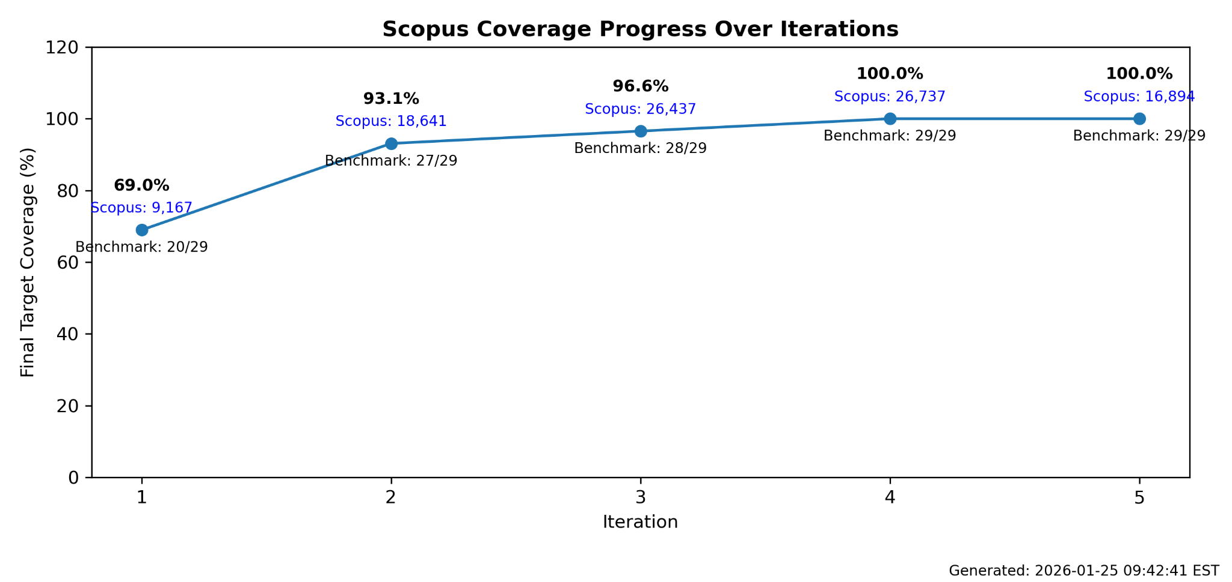
Figure 2: Scopus benchmark retrieval coverage across search-string iterations

3.3 Deduplication
Searches across all 28 sources retrieved 40,653 records prior to deduplication. Bibliographic databases contributed 39,949 records: Scopus (17,021), Web of Science (15,170), CAB Abstracts (5,723), Academic Search Premier (1,187), EconLit (478), ProQuest (367), and AGRIS (3). Web search engines contributed 196 records: Google Scholar (193) and DuckDuckGo (3). Organisational and grey literature websites contributed 489 records across 20 sources: Green Climate Fund (157), Inter-American Development Bank (123), CGSpace/CGIAR (65), UNFCCC (28), World Bank (28), IFAD (16), Asian Development Bank (16), UNDP (9), IPAM (7), GEF (7), WASP (6), 3ie (5), Adaptation Research Alliance (5), African Development Bank (5), Global Center on Adaptation (3), Campbell Collaboration (3), UNEP (2), FCDO (2), FAO (2), and J-PAL (searched; no relevant results). USAID's Development Experience Clearinghouse was taken offline in 2025 and could not be searched.
Records were deduplicated in two stages. First, within-Scopus deduplication reduced 17,083 raw Scopus records to 17,021 unique records using DOI matching, followed by normalised title and year matching. Second, all records from non-Scopus sources were deduplicated against the Scopus corpus to identify net-new records not already captured. Deduplication applied three criteria in priority order: (1) exact DOI match; (2) exact title and year match; (3) fuzzy title similarity using the Jaccard coefficient (threshold ≥ 0.85), applied within the same publication year. A record was classified as a duplicate if it matched on any of the three criteria. Of 23,613 non-Scopus records, 9,152 were net-new. After both stages of deduplication, 26,173 unique records entered title and abstract screening.

3.4 Screening strategy

Screening proceeded in two sequential stages: (1) title and abstract screening, and (2) full-text screening. At each stage, records were assessed against the pre-specified eligibility criteria (Table 2). Screening decisions and reasons for exclusion at full-text stage were recorded to ensure transparency and reproducibility. In line with systematic map best practice, screening at the title and abstract stage was intentionally inclusive, with studies retained wherever relevance was uncertain.

3.4.1 Eligibility criteria
Eligibility criteria were defined around the PCCM framework and applied consistently at both the title/abstract and full-text screening stages. Studies were assessed against eight criteria covering population, concept, context, methodology, publication period, language, publication type, and geographic scope. At the title and abstract stage, uncertain cases were retained for full-text review. At the full-text stage, reasons for exclusion were recorded for each excluded study.
Table 2: Eligibility Criteria
Category | Inclusion Criteria | Exclusion Criteria
Population | Studies examining climate change adaptation interventions targeting smallholder producers and related agricultural production systems—defined as individuals or households engaged in small-scale production across crops, livestock, fisheries/aquaculture, and forestry. | Studies focusing on populations other than smallholder producers, such as large-scale commercial agriculture, agribusiness value chains without a smallholder focus, or non-agricultural livelihoods.
Concept | Included studies assess or document adaptation processes or outcomes, such as changes in capacities, practices, or resilience. Studies need not explicitly use the term “adaptation,” but must describe interventions aligned with adaptation objectives (e.g., reducing climate risks, enhancing climate resilience, or improving coping capacity). | Studies that address climate change mitigation only or general development objectives without an explicit or implicit focus on climate risk, climate resilience, or adaptive capacity and therefore do not assess adaptation processes or outcomes.
Context | Studies conducted within agricultural settings in LMICs that are exposed to climate hazards or climate-stress conditions and are framed in relation to climate change, climate variability, or climate risk. Eligible contexts include crop, livestock, fisheries/aquaculture, or forestry systems where climate-related stressors (e.g., drought, flooding, temperature extremes, rainfall variability) are relevant to agricultural production and adaptation decision-making. Studies must situate interventions, outcomes, or analyses within an explicit climate–agriculture context consistent with adaptation framing. | Studies conducted outside agricultural sector domains or without reference to climate hazards, climate-stress conditions, or climate risk framing. This includes studies addressing agricultural systems without a climate dimension, climate impacts or responses unrelated to agriculture, or development or environmental studies that do not explicitly link climate stressors to agricultural production or adaptation processes.
Methodology | Studies that describe, propose, apply, or evaluate a method, tool, framework, or set of indicators intended to assess climate change adaptation processes or outcomes.  Adaptation processes: The processes of adjustments in ecological, social, or economic systems to moderate potential damages and benefit from opportunities from climate change.  Adaptation outcomes: The results of adjustments in ecological, social, or economic systems to moderate potential damages and benefit from opportunities from climate change.  Eligible studies may include conceptual or methodological frameworks, modeling or simulation studies, pilot applications, or evaluations, provided they present sufficient methodological detail to understand the structure, intended use, and measurement approach of the method (e.g., indicators, data requirements, analytical logic). | Studies that do not present a discernible method or measurement approach (e.g., purely narrative discussions, opinion pieces, or general conceptual commentary without methodological specification), or that lack sufficient detail to allow the method to be meaningfully classified or compared.
Publication Period | Published between 2005–2025, capturing contemporary adaptation evaluation methods post-IPCC AR4 (2007) and emergence of National Adaptation Programmes of Action. | Publications before 2005.
Language | English, French, or Spanish. | Other languages.
Publication Type | Academic and gray literature from reputable sources (multilateral organizations, bilateral donors, international NGOs, national research institutes, recognized evaluation units). | Unclear or non-reputable sources.
Geographic Scope | Single or multi-country studies including at least one LMIC. | Studies exclusively in high-income countries.

3.4.2 Consistency checking
Consistency checking was undertaken to assess the replicability and reliability of screening decisions. Two independent human reviewers (C. Staub and J. Cissé) screened calibration samples separately, then reconciled disagreements into a gold-standard decision for every record. The LLM screener was assessed against this gold standard after each round, and eligibility criteria were revised between rounds until performance thresholds were met. A kappa score of ≥ 0.6 was set as the minimum acceptable threshold for inter-rater agreement, consistent with CEE guidelines.
Six calibration rounds were conducted across approximately 520 records in total. Sensitivity rose from 0.776 in Round 1 to 0.966 at deployment (Round 2b), meeting the O'Mara-Eves et al. (2015) threshold of ≥ 0.95. A stability check on an independent sample of 107 records (Round 3a) confirmed sensitivity of 0.970. Cohen's κ between the LLM and the human gold standard reached 0.720 (substantial agreement) at deployment; human inter-rater κ was 0.765. Full calibration results are presented in Table 3 and Figure 3.
Table 3: Screening calibration results across six rounds. Bold = deployment round.
Round | n | Sensitivity | Specificity |  | Precision | F1 | κ (LLM vs gold) | Human κ
R1 — initial | 205 | 0.776 |  | 0.703 | 0.559 | 0.650 | 0.436 | 0.500
R1a — 1st revision | 205 | 0.761 |  | 0.797 | 0.646 | 0.699 | 0.534 | 0.500
R1b — 2nd revision | 205 | 0.866 |  | 0.819 | 0.699 | 0.773 | 0.645 | 0.500
R2a — 3rd revision | 103 | 0.897 |  | 0.905 | 0.788 | 0.839 | 0.770 | 0.765
R2b | 103 | 0.966 |  | 0.838 | 0.700 | 0.812 | 0.720 | 0.765
R3a | 107 | 0.970 |  | 0.824 | 0.711 | 0.821 | 0.721 | 0.703
O'Mara-Eves target | — | ≥ 0.95 |  | — | — | — | ≥ 0.60 | —
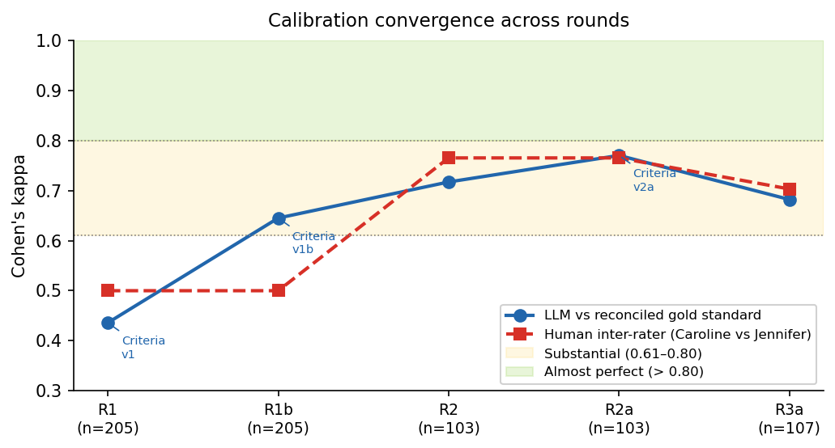
Figure 3: LLM screener performance across six calibration rounds. Shaded bands indicate published benchmarks (O'Mara-Eves et al. 2015; Hanegraaf et al. 2024). All five metrics met or exceeded their respective targets at Round 2b.
The validated screener was applied to all 26,173 records at full-corpus screening. Final inclusion and exclusion decisions are documented alongside the screening outputs to ensure transparency and compliance with CEE systematic map standards.

3.5 Data coding strategy

A structured data extraction form was implemented in a coded spreadsheet. Coding was iterative and piloted on a subset of studies prior to full data extraction. The coding framework was refined during early extraction to accommodate emerging patterns, with all changes documented and justified.

3.5.1 Meta-data to be coded
The variables to be extracted for each included study, along with their definitions and data types, are presented in Table 4.

Table 4. Data extraction variables and data types
Variable | Description | Data type | Notes
Study ID | Unique identifier for each included study | System-generated ID | Assigned in EPPI-Reviewer
Publication year | Year of publication | Numeric (year) | If multiple versions, use most recent
Publication type | Type of publication | Categorical (single-select) | Journal article; report; working paper; thesis; other
Country/region | Country or region(s) covered by the study | Categorical (multi-select) | Enter countries when specified; use a region label only if countries are not provided (separate multiple entries with semicolons).
Geographic scale | Spatial scale of analysis | Categorical (single-select) | Local; sub-national; national; multi-country; regional
Producer type(s) | Type of agricultural producers studied | Categorical (multi-select) | Crop; livestock; fisheries/aquaculture; agroforestry; mixed; undefined
Marginalized subpopulations | Whether the study explicitly addresses marginalized groups | Categorical (multi-select) | Women; youth; landless; Indigenous Peoples; ethnic minorities; migrant/seasonal workers; people with disabilities; other; none reported
Adaptation focus | Type of adaptation action or intervention assessed | Emergent coding | Developed iteratively during extraction
Methodological approach | Primary methodological design | Categorical (single-select) | Qualitative; quantitative; participatory; modeling with empirical validation; experimental;
Purpose of assessment | Primary purpose of the assessment | Categorical (single-select) | Project learning; program evaluation; donor reporting; national reporting; research
Indicators measured | Types of indicators used | Emergent coding | E.g., resilience, vulnerability, exposure, adaptive capacity
Process and outcome domains assessed | Specific domains of adaptation processes and/or outcomes assessed in the study | Categorical (multi-select) | Process domains: Knowledge, awareness, or learning; Decision-making or planning; Uptake or adoption of practices; Behavioral change; Participation or co-production; Institutional or governance processes; Access to information, services, or resources. Outcome domains: Yields or productivity; Income or assets; Livelihoods; Wellbeing; Risk reduction or loss avoidance; Resilience or adaptive capacity
Data sources | Data sources used in the study | Categorical (multi-select) | Surveys; administrative data; remote sensing; participatory methods; secondary data; other
Temporal coverage | Time horizon of the study | Categorical (single-select) | Cross-sectional; seasonal; longitudinal; repeated cross-sectional
Cost data reported | Whether cost or resource requirements are reported | Binary (yes/no) | No cost standardization attempted
Strengths and limitations | Author-reported strengths and limitations | Free text | Extract verbatim where possible
Lessons learned | Key lessons or recommendations reported | Free text | Used for narrative synthesis
Validity-related notes | Descriptive notes on internal/external validity | Free text | Not a formal critical appraisal

3.5.2. Consistency checking
Prior to production coding, a calibration round (FT-R1a) was conducted on 5 papers coded independently by multiple reviewers. Agreement was assessed field-by-field using percentage agreement, and discrepancies were discussed to refine extraction guidance. The codebook was updated following calibration before production coding proceeded.
Production coding proceeded in 9 batches across 151 human-coded papers. Spot-checks were conducted across batches; discrepancies were discussed and resolved to maintain consistency throughout.

3.6 Coding and information saturation
Data extraction was conducted by five trained research assistants using a standardised codebook. Of the papers included for full-text screening, studies were drawn in batches of 20 using a random sample; the same random starting point was used each time to ensure the process was reproducible. Each batch excluded papers already coded in prior batches, ensuring no paper was coded twice. Coders applied the five PCCM inclusion criteria to confirm inclusion, then completed 16 extraction fields (country, scale, producer type, adaptation focus, domain, methodology, equity, etc.). A coding calibration exercise was conducted on a subset of 5 studies (R1a) in which the research assistants independently coded the same papers; disagreements were reviewed and adjudicated by the lead reviewer to ensure consistency. Where systematic disagreements indicated ambiguity in field definitions, the codebook was updated with clarifying guidance before production coding proceeded, and all coders were briefed on the updates.
Information saturation was tracked at each batch across three dimensions: process/outcome domains (13 canonical values), methodological approaches (5), and producer types (5). As shown in Figure 4, All three dimensions reached saturation within the initial few batches (49 papers coded) with zero new canonical categories added across any of the six subsequent batches (99 additional papers). Across nine batches, 180 papers were drawn for coding; 151 met the inclusion criteria.
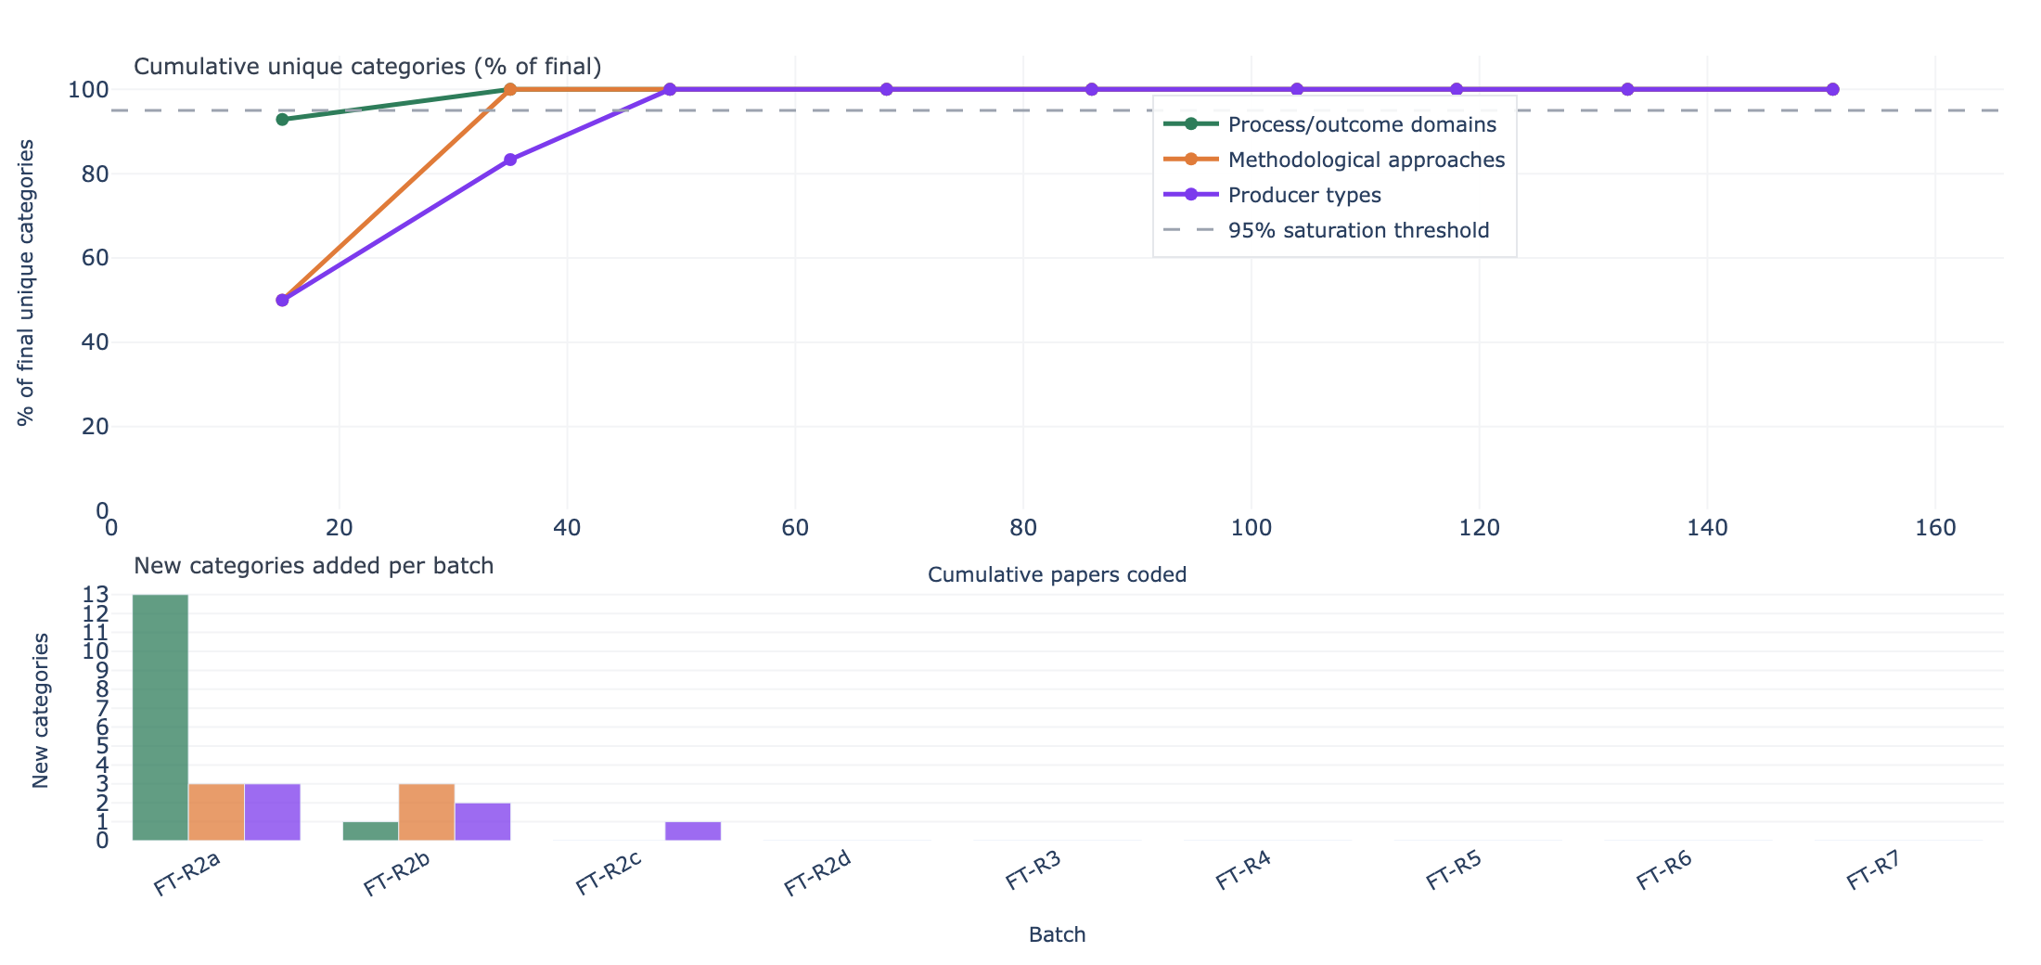
Figure 4: Information saturation curve across nine coding batches

3.5 Evidence Map Construction
The evidence map was constructed as a two-dimensional matrix of process/outcome domains (rows) against producer types (columns). Thirteen canonical process and outcome domains were used as rows: seven process domains (access to information and services, behavioural change, decision-making and planning, institutional governance, knowledge and awareness, participation and co-production, and uptake and adoption) and six outcome domains (income and assets, livelihoods, resilience and adaptive capacity, risk reduction, wellbeing, and yields and productivity). Five producer types were used as columns (crop, livestock, fisheries and aquaculture, agroforestry, and mixed). Each cell represents the number of studies tagged with that domain and producer type combination; studies may appear in multiple cells where more than one domain or producer type was coded. Cells with no studies represent evidence gaps. The map was produced in both static (PNG) and interactive (HTML) formats; the interactive version is available at https://bristlepineconsulting.com/projects/ilri01/systematic-map#evidence-map.

4. Final results

4.1 Search and screening summary
A total of 40,653 records were identified across eight bibliographic databases and 20 grey literature sources. After deduplication, 26,173 unique records entered title and abstract screening. The validated LLM screening tool identified 8,753 records for full-text assessment. Papers were coded in batches of 20 by research assistants. Of 180 papers drawn across nine batches, 154 met the inclusion criteria; additional batches are in process.
Table 5. Search and screening results by database

Database | Returned | After dedup | Abstr. incl.
Scopus | 17,021 | 17,021 | 6,218
Web of Science | 15,179 | 4,683 | 1,137
CAB Abstracts | 5,723 | 3,229 | 1,133
Academic Search Premier | 1,187 | 274 | 66
AGRIS | 3 | 1 | 1
EconLit | 479 | 263 | 83
ProQuest | 368 | 117 | 40
Google Scholar | 198 | 100 | 34
Grey literature (20 sources) | 495 | 485 | 41
Total | 40,653 | 26,173 | 8,753

Table 5 and Figure 5 presents the PRISMA flow diagram showing record flow across 28 sources and all screening stages.
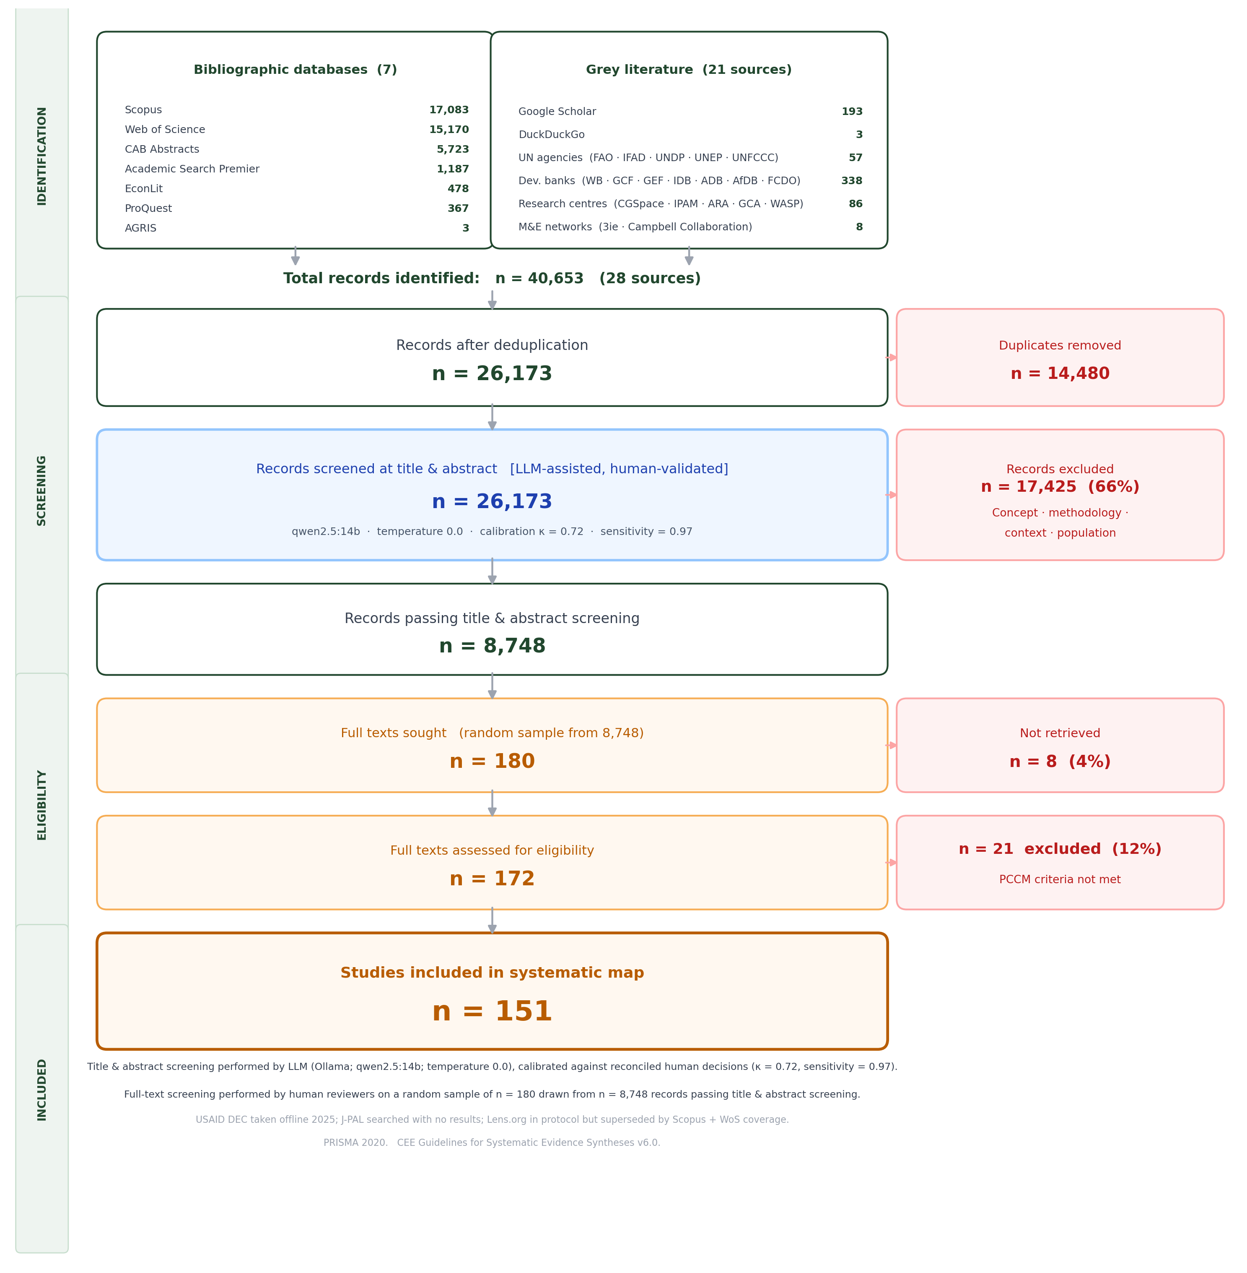
Figure 5. PRISMA flow diagram.

4.2 Evidence map
The evidence map shown in Figure 6 is the primary output of this deliverable. It plots the distribution of coded studies (n = 154) across process and outcome domains (y-axis) and producer types (x-axis). Bubble size is proportional to the number of studies in each cell. Grey circles indicate evidence gaps with no studies in that combination.
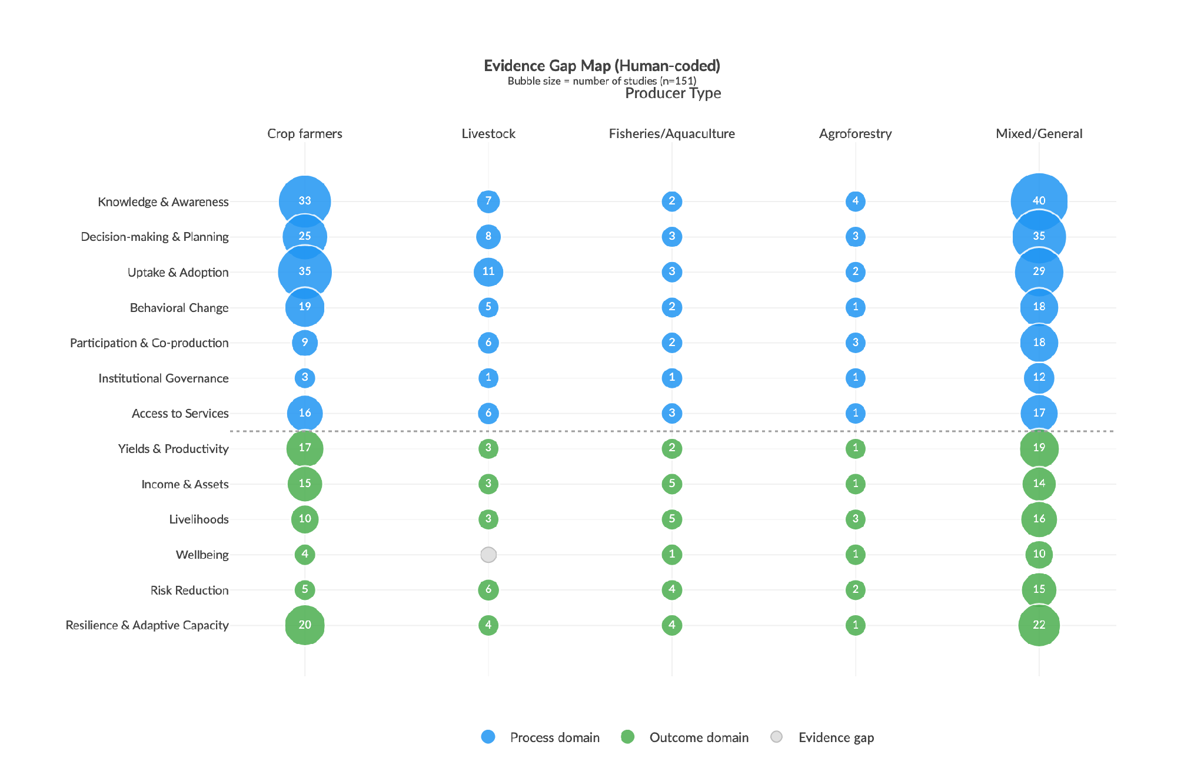Figure 6. Evidence map results (n = 154). Blue = process domains · green = outcome domains · grey = evidence gaps. Bubble area ∝ number of studies.
Key observations:
- Process-oriented measures dominate. Decision-making & planning, knowledge & awareness, and uptake & adoption are the most studied domains, especially for crop farmers.
- Outcome-oriented measures are nearly absent. Income & assets, wellbeing, risk reduction, and resilience are sparsely covered, and almost exclusively for crop systems. The evidence gap visualizes this limitation, showing a clustered abundance of research on whether crop farmers are trying to adapt, but limited evidence on whether these efforts are actually improving their long-term adaptive capacity and wellbeing.
- Over-representation of Crop Farmers. Non-crop producer types are systematically uncovered. Livestock, fisheries, agroforestry, and mixed-system producers appear in very few cells; most cells for these types are gaps.
- Institutional governance and access to services remain among the least-studied domains: 18 and 35 studies respectively across all producer types (18 and 35 of 604 study-domain instances).

4.3 Geographic distribution
Figure 7 and Figure 8 show that studies are heavily concentrated in Sub-Saharan Africa and South Asia. Ethiopia, Ghana, and Kenya alone account for 22% of all human-coded studies. Large evidence gaps persist across Central America, Southeast Asia, the Sahel, and MENA.

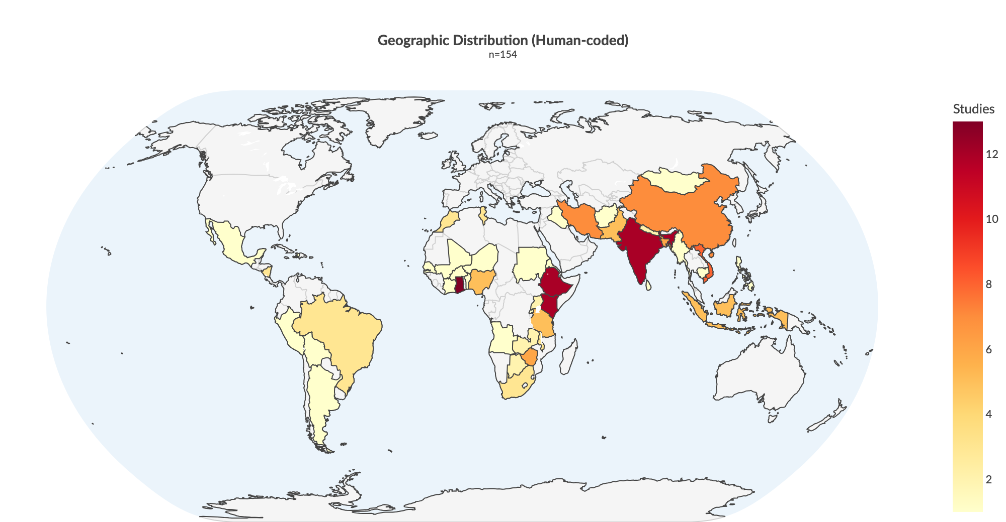
Figure 7. Geographic distribution of included studies.

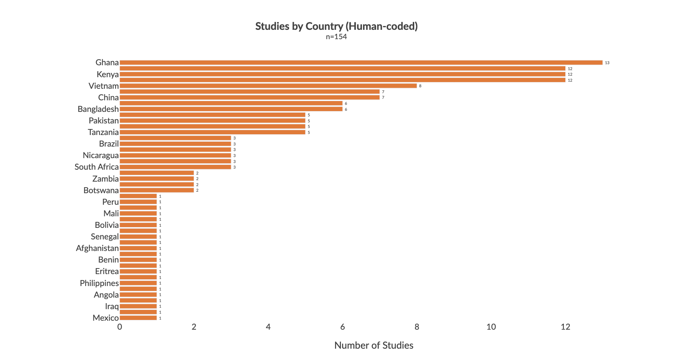
Figure 8. Top countries by study count.

4.4 Methodological approaches

Quantitative and qualitative approaches dominate the evidence base, accounting for 110 and 82 studies respectively (Figure 9). Experimental designs, including randomised controlled trials and quasi-experimental studies, represent only 8% of the corpus (12 of 154 studies), severely limiting causal inference about adaptation effectiveness. Participatory approaches are common, appearing in 25% of studies, particularly for process-level outcomes. Mixed methods and modelling are rare (4% and 9% respectively). This heavy reliance on observational approaches, and the near absence of experimental or longitudinal designs, means the current literature maps the uptake and awareness of adaptation strategies well but cannot prove whether they work.

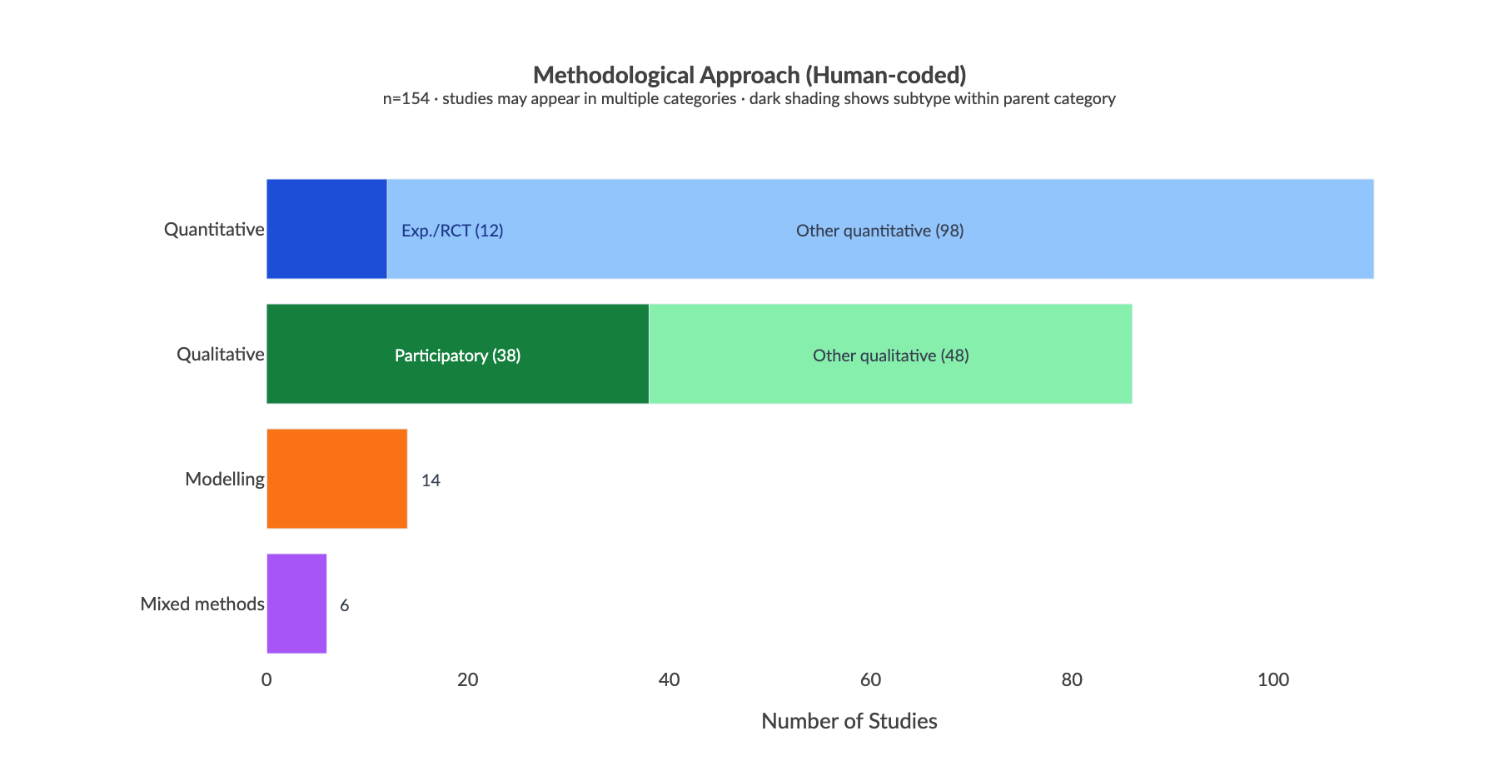
Figure 9. Methodological approaches across included studies.

4.5 Equity and inclusion
There is a significant gap in how adaptation research addresses social vulnerability. Figure 10 shows that 38% of included studies make no reference to any marginalized group. Where groups do appear, the focus is heavily skewed: women feature in ~35% of studies and youth in ~29%. Beyond these two groups, the evidence base drops sharply with indigenous peoples, landless communities, ethnic minorities, and migrant workers each appearing in fewer than 5% of studies, and people with disabilities and the elderly in fewer than 2%.
This concentration on women and youth, while valuable, masks the absence of evidence for other highly vulnerable populations. The literature largely treats smallholder farmers as a homogenous group, ignoring how intersecting vulnerabilities (disability, land tenure, ethnicity, age) shape an individual's capacity to adapt to climate shocks. Because studies rarely measure how specific subgroups respond to interventions, future climate resilience programmes risk relying on generic capacity-building models that overlook the distinct needs of the most marginalised.

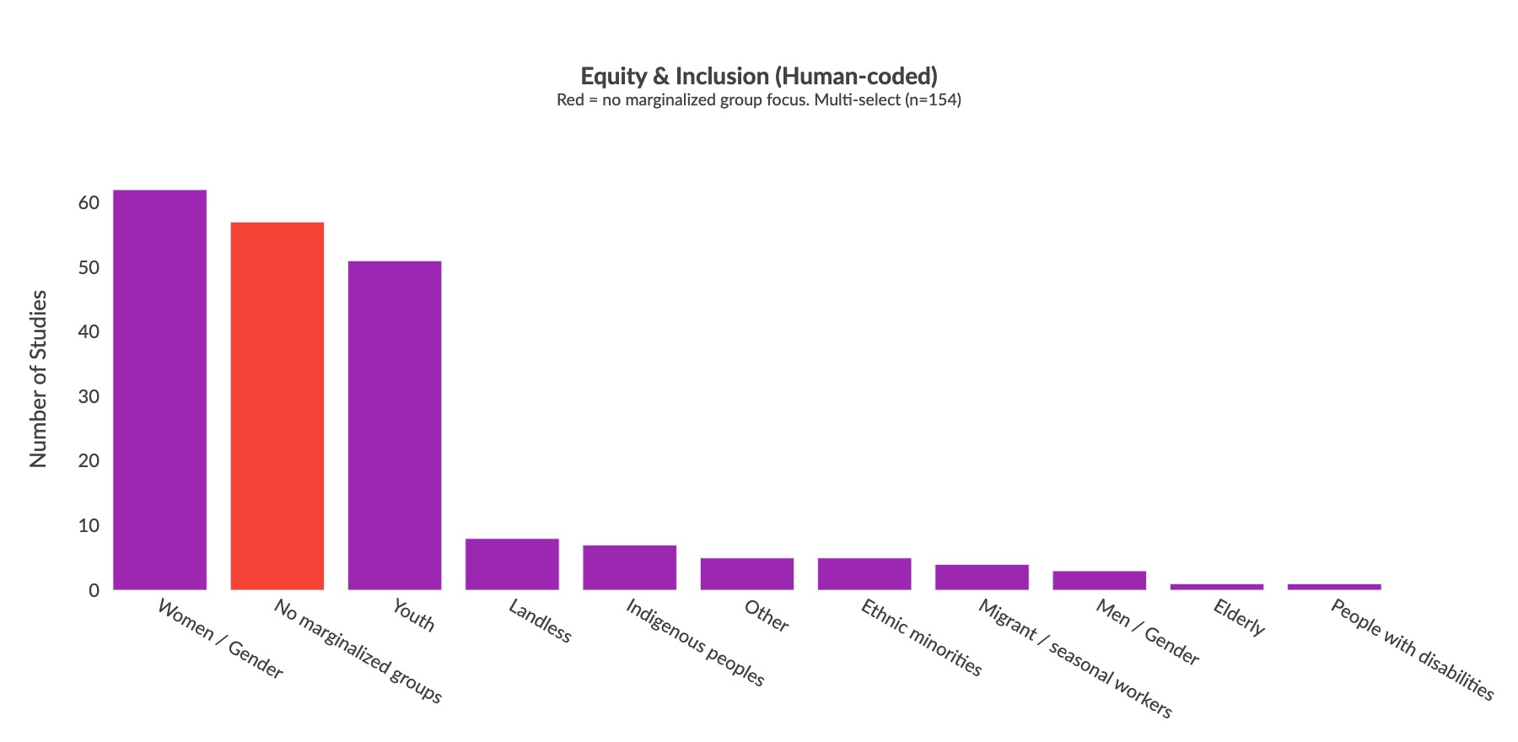
Figure 10. Equity and inclusion dimensions across included studies. Red bar = studies with no marginalized group focus.

4.6 Publication trends and saturation
Annual publications increased more than five-fold between 2005–2014 (average 2 studies per year) and 2015–2024 (average 11 per year), peaking in 2021 (Figure 11). The evidence base is almost entirely contemporary with fewer than 10% of included studies predating 2015, meaning long-term impact evidence remains very thin.

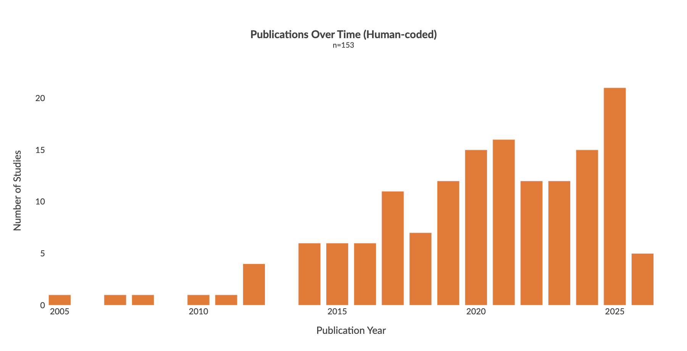
Figure 11. Publication trends across included studies.

4.7 Temporal and geographic patterns
Figure 12 shows how research focus has shifted over time. Process domains, particularly knowledge and awareness (51 studies), decision-making and planning (40), and uptake and adoption (41), dominate across all three periods and have grown substantially since 2020. Outcome domains remain sparse in absolute terms, though resilience and adaptive capacity has grown from 6 studies before 2015 to 38 since 2020, suggesting a gradual shift toward measuring impact rather than just process.
Figure 13 shows how producer type coverage varies by region. Crop farmer studies dominate in every region. Sub-Saharan Africa has the most diverse coverage, with 22 crop farmer studies and 13 livestock studies. Fisheries/aquaculture and agroforestry are nearly absent from MENA and Latin America, with zero studies in most cells. This confirms that the producer bias seen in the evidence map is consistent across regions and not driven by any single geography.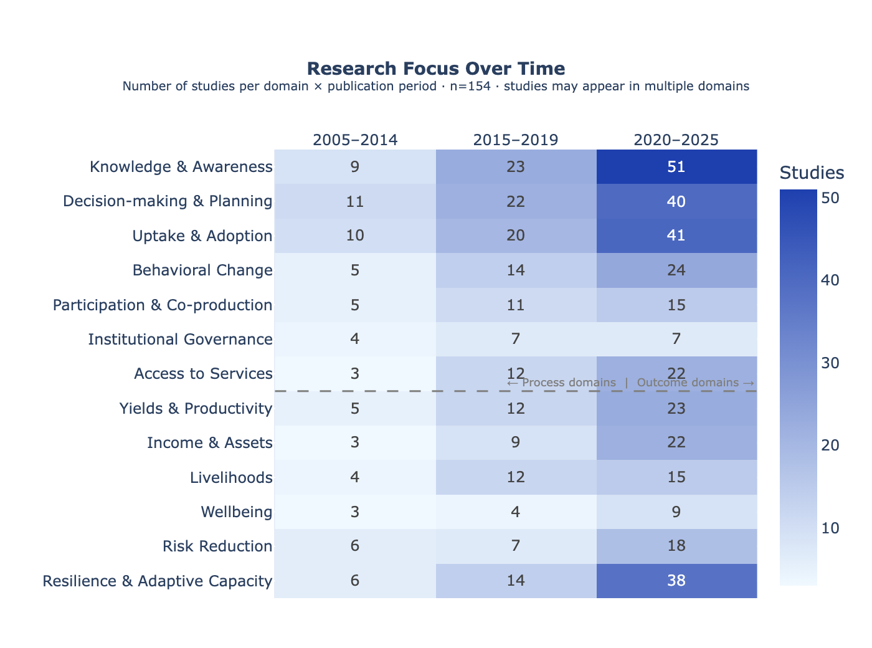
Figure 12. Research focus by publication period. Rows = process/outcome domains; columns = publication period. Cell values = number of studies. Studies may appear in multiple domains.
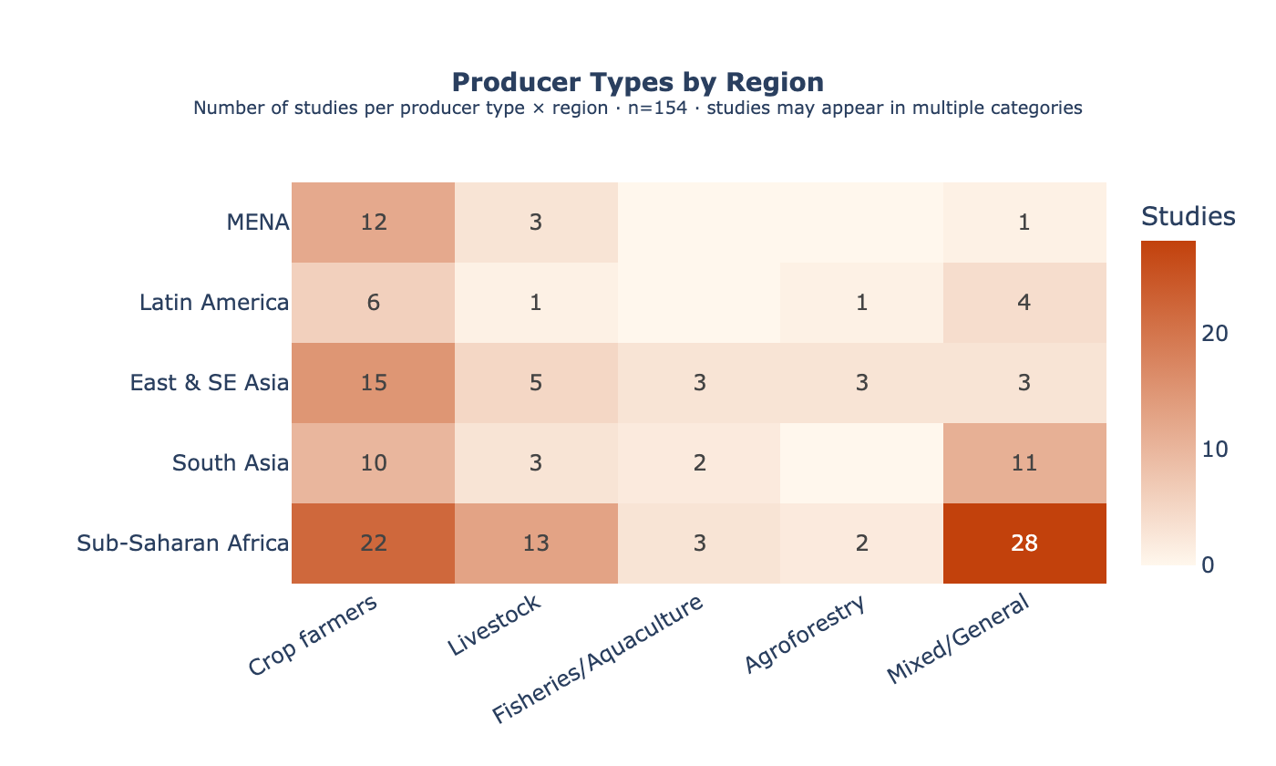
Figure 13. Producer type coverage by region. Rows = region; columns = producer type. Cell values = number of studies. Blank cells = no studies.

5. Searchable Database
- An interactive evidence map is available at https://main.d3a9jahzuu7xai.amplifyapp.com/systematic-map#evidence-gap-map
- A searchable database of all included studies is available at https://main.d3a9jahzuu7xai.amplifyapp.com/systematic-map#searchable-database
- All code and data: [Zenodo DOI — to be assigned upon final release]

6. Conclusions
The evidence map reveals a systematic mismatch between what adaptation M&E currently measures and what is needed to understand adaptation effectiveness.
- Process-oriented outcomes are well-documented, impact-oriented outcomes are not. The literature reliably captures whether farmers adopted a practice or gained knowledge. It almost never measures whether adaptation improved incomes, wellbeing, or resilience.
- Non-crop producer types are almost entirely unmeasured. Livestock, fisheries, agroforestry, and mixed-system producers appear in very few cells of the evidence map. Most are pure gaps.
- Geographic concentration limits generalisability. Three countries account for 22% of all studies. The evidence base cannot support regional conclusions across most LMICs.
- The equity gap is the most critical for policy. 38% of studies make no reference to any marginalized group; of the 60% that do, coverage is almost entirely limited to women and youth. Disability, ethnicity, age, and land tenure appear in 5% or fewer of studies each. We cannot tell whether adaptation is reaching the most vulnerable populations.
- A lack of robust experimental evidence limits causal inference. While cross-sectional quantitative and qualitative methods are abundant, rigorous experimental designs are exceptionally rare. This makes it difficult to definitively prove whether specific capacity-building or adaptation interventions actually cause improvements in long-term resilience, rather than merely showing correlations with practice adoption.
Addressing these gaps requires investment in long-term cohort studies, equity-disaggregated data collection, and research that targets non-crop livelihood systems. A follow-on systematic review is planned to build on this evidence map.

7. Acknowledgements
This work was funded by the International Livestock Research Institute (ILRI) under the CGIAR Initiative on Climate Resilience (ClimBeR). The authors thank the ILRI project team for their guidance and stakeholder engagement support throughout the protocol development and screening process. The systematic map protocol was peer-reviewed by an independent Methods Advisor and informed by feedback from the CGIAR and ILRI stakeholder network.

8. References
- Bristlepine Resilience Consultants (2026). Deliverable 3: Final Systematic Map Protocol — Measuring what matters: tracking climate adaptation processes and outcomes for smallholder producers in the agriculture sector. January 2026, v3. Zenodo. https://doi.org/10.5281/zenodo.19811629
- Collaboration for Environmental Evidence (2018). Guidelines and Standards for Evidence Synthesis in Environmental Management. Version 5.1. Pullin AS, Frampton GK, Livoreil B, Petrokofsky G (eds). https://www.environmentalevidence.org/guidelines
- Haddaway, N.R., Macura, B., Whaley, P. and Pullin, A.S. (2018). ROSES Reporting standards for Systematic Evidence Syntheses: pro forma, flow diagram and descriptive summary of the plan and conduct of environmental systematic reviews and systematic maps. Environmental Evidence, 7, 7. https://doi.org/10.1186/s13750-018-0121-7

